**DAILY ONLINE ACTIVITIES SUMMARY**

|  |  |  |  |  |  |  |  |  |
| --- | --- | --- | --- | --- | --- | --- | --- | --- |
| **Date:** | 26-06-2020 | | | | | **Name:** | Anvitha H M | |
| **Sem & Sec** | 4th ‘A’ | | | | | **USN:** | 4AL18CS010 | |
| **Online Test Summary** | | | | | | | | |
| **Subject** | | - | | | | | | |
| **Max. Marks** | | 30 | | **Score** | | | - | |
| **Certification Course Summary** | | | | | | | | |
| **Course** | Introduction to R. | | | | | | | |
| **Certificate Provider** | | | Great learning academy | | **Duration** | | | 5 hours |
| **Coding Challenges** | | | | | | | | |
| **Problem Statement:** C program to reverse an array by swapping (without using additional memory). | | | | | | | | |
| **Status:** Executed | | | | | | | | |
| **Uploaded the report in Github** | | | | | YES | | | |
| **If yes Repository name** | | | | | <https://github.com/alvas-education-foundation/Anvitha-H-M> | | | |
| **Uploaded the report in slack** | | | | | Yes | | | |

**Online test:**

N/A

**Certification course:**

Introduction to R.

The course includes detailed explanation on importing data, data manipulation, sorting, merging, data summaries and exporting data.

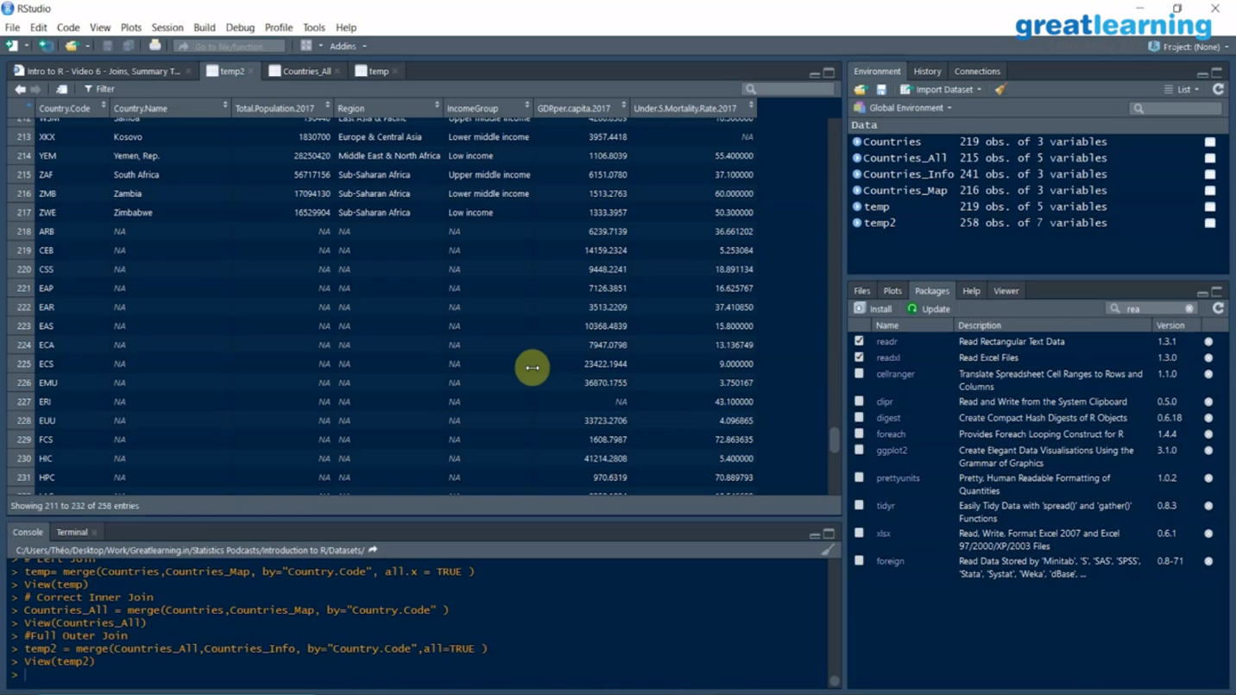

Online coding challenge

The programing statement of the day is

“C program to reverse an array by swapping(without using additional memory).”.

Solution: Executed and uploaded in Github repository.

Link: <https://github.com/alvas-education-foundation/Anvitha-H-M>

